Cover page

Table of contents

SOFTWARE REQUIREMENTS SPECIFICATION
a) LLM details
- LLM used: ChatGPT
- Model version: GPT-5.2 (free subscription)
- Date accessed: 28th January 2026
- Prompt used:
“Generate a requirements specification for the following task:
Task 4: Traffic Light…
The purpose of this program is to navigate the SwiftBot using colour codes detected by its camera. The program should process images of traffic lights displaying three colours: red, green, and blue. The red and green traffic lights follow standard traffic conventions: red signals the SwiftBot to stop, while green indicates it should proceed forward. The blue light represents a special scenario where the SwiftBot must temporarily yield its path - similar to how vehicles give way to emergency vehicles in real-world situations. While actual lights can be used, coloured images may be substituted. The SwiftBot should respond to traffic lights when they are within 20 cm of its position. The program should process the photo taken by the SwiftBot’s camera to determine the colour of the traffic light. One recommended approach is to convert the image into a pixel matrix and use the RGB values of each pixel to compute an average colour value. This average colour value can then be used to determine the traffic light colour. To start the program, the user must press button ‘A’ on the SwiftBot. This should make the SwiftBot, first, turn the underlights to yellow, and, then, start moving forward at a low speed (initial speed) until it encounters the traffic light. The program should display the initial speed to the user. The SwiftBot should respond to the traffic light when it is 30 cm (or less) ahead of the robot. Your program should check for traffic lights at regular intervals while the SwiftBot is moving. Choose an appropriate time interval, according to your initial speed, to ensure reliable detection. When a traffic light is detected, the program should display both its colour and its distance from the SwiftBot. Upon detecting a green light, the underlights should be set to green and the SwiftBot should pass the traffic light within 2 seconds. After passing the traffic light, the SwiftBot should stop for a second, set the underlights to yellow, and then the robot should move forward in its initial speed until it detects the next traffic light. The appropriate forward speed can be calculated through experimentation with your SwiftBot using simple mathematics (refer Calibrate Your SwiftBot worksheet for more guidance). Upon detecting a red light, the SwiftBot should set its underlights to red and the SwiftBot should come to a stop at the traffic light. After a second, the SwiftBot should start moving forward at its initial speed until it detects the next traffic light. Upon detecting a blue light, the SwiftBot should stop for a second, blink the underlights in blue and then, should turn left by 90 degrees. The robot should then move forward at a low speed for 1 second and stop. After a second, the SwiftBot should retrace its movement and move back to the original path. Then the robot should move forward at its initial speed until it detects the next traffic light. The program terminates when the user presses the 'X' button on the SwiftBot. After every three lights detected (i.e., after the 3rd light, 6th light, 9th light, and so on) and after completing the navigation for the third light, the user should be prompted to either terminate the program or continue. Before terminating, it should ask the user whether to display the execution log. If the user presses button 'Y', the program should display the following information: the number of times the SwiftBot encountered traffic lights, the most frequent traffic light colour the SwiftBot encountered, the number of times the most frequent traffic light was detected, and the total duration of execution. If the user does not want to view the log, the user should press button ‘X’ again. In either case, the program should write the log information to a text file before terminating and display the location of the log file to the user before terminating. This program should be implemented using a command-line user interface (input and output printed in the command prompt). Your program should make appropriate error checks and exception handling in order to ensure that the input values are within the valid range specified in the task description. Invalid input should be rejected, and informative error messages should be displayed, prompting the user for new input. The software should be designed to enhance user experience and ease of use.”

b) LLM generated Software Requirements Specification
“Software Requirements Specification (SRS)
Task 4: Traffic Light Navigation System for SwiftBot
1. Introduction
1.1 Purpose
The purpose of this document is to specify the functional and non-functional requirements for a SwiftBot control program that enables autonomous navigation based on traffic light colour detection using the onboard camera. The system interprets red, green, and blue traffic lights and performs predefined navigation behaviours accordingly.
1.2 Scope
The software will:
- Control SwiftBot movement based on detected traffic light colours.
- Use image processing to determine traffic light colour.
- Interact with the user via a command-line interface (CLI).
- Maintain and store an execution log.
- Allow user control for starting, continuing, and terminating execution.
The system is intended for educational and experimental use with either real traffic lights or coloured images.
1.3 Definitions and Acronyms
- SwiftBot: A mobile robot platform with camera, motors, lights, and buttons.
- CLI: Command Line Interface.
- RGB: Red, Green, Blue colour model.
- Initial Speed: Low forward speed set at program start.
2. Overall Description
2.1 Product Perspective
This software runs as a standalone command-line application that interfaces with SwiftBot hardware components including:
- Camera
- Motors
- Underlights
- Buttons (A, X, Y)
2.2 User Characteristics
Users are expected to have:
- Basic familiarity with command-line programs
- Introductory knowledge of robotics and programming
No advanced technical expertise is assumed.
2.3 Operating Environment
- Hardware: SwiftBot robot
- Software: Command-line environment (e.g. terminal)
- Camera-based image capture
- File system access for log storage
2.4 Assumptions and Constraints
- Traffic lights are within 30 cm of the robot for detection.
- The robot moves on a flat surface.
- Lighting conditions are sufficient for colour detection.
- Button inputs are functional and responsive.
3. Functional Requirements
3.1 Program Start and Termination
FR1: The program shall start only when the user presses button A.
FR2: Upon start, the SwiftBot shall:
- Set underlights to yellow
- Begin moving forward at the initial speed
- Display the initial speed in the CLI
FR3: The program shall terminate when the user presses button X, subject to confirmation rules described in Section 3.6.
3.2 Traffic Light Detection
FR4: The SwiftBot shall capture images using its camera at regular time intervals while moving.
FR5: The image shall be converted into a pixel matrix.
FR6: The system shall compute the average RGB value across all pixels.
FR7: The system shall classify the traffic light as red, green, or blue based on the average RGB value.
FR8: The system shall respond only to traffic lights detected at a distance of 30 cm or less.
FR9: When a traffic light is detected, the system shall display:
- The detected colour
- The estimated distance from the SwiftBot
3.3 Green Light Behaviour
FR10: Upon detecting a green traffic light:
- Underlights shall be set to green
- The SwiftBot shall pass the traffic light within 2 seconds
- After passing, the robot shall:
  - Stop for 1 second
  - Set underlights to yellow
  - Resume movement at the initial speed
3.4 Red Light Behaviour
FR11: Upon detecting a red traffic light:
- Underlights shall be set to red
- The SwiftBot shall stop at the traffic light
- After 1 second, the robot shall resume movement at the initial speed
3.5 Blue Light Behaviour
FR12: Upon detecting a blue traffic light, the SwiftBot shall:
- Stop for 1 second
- Blink underlights in blue
- Turn left by 90 degrees
- Move forward at low speed for 1 second
- Stop for 1 second
- Retrace its movement back to the original path
- Resume forward motion at the initial speed
3.6 User Interaction and Execution Control
FR13: The program shall keep a count of detected traffic lights.
FR14: After every third traffic light detected, the user shall be prompted to:
- Continue execution
- Terminate the program
FR15: If the user chooses to terminate:
- The system shall ask whether to display the execution log
- Button Y shall display the log
- Button X shall skip log display
3.7 Execution Logging
FR16: The system shall record:
- Total number of traffic lights detected
- Most frequently detected traffic light colour
- Number of times the most frequent colour occurred
- Total execution duration
FR17: The system shall write the execution log to a text file before termination.
FR18: The system shall display the file location of the log to the user before exiting.
4. Non-Functional Requirements
4.1 Usability
NFR1: The system shall use clear and informative CLI messages.
NFR2: Error messages shall explain the issue and guide corrective action.
4.2 Reliability
NFR3: The system shall continue operating reliably under repeated traffic light detections.
NFR4: Invalid inputs shall not cause system crashes.
4.3 Performance
NFR5: Image processing and detection shall be fast enough to respond within the 30 cm detection range.
NFR6: Traffic light detection intervals shall be chosen to ensure accuracy at the selected initial speed.
4.4 Maintainability
NFR7: The software shall be modular, separating:
- Image processing
- Movement control
- User interaction
- Logging functionality
5. Error Handling and Validation
ER1: Invalid button inputs shall be rejected with an informative message.
ER2: Camera capture or image processing failures shall be handled gracefully.
ER3: File write errors shall be reported to the user.
6. Future Enhancements (Optional)
- Adaptive speed control based on distance
- Support for additional traffic light colours
- Graphical user interface (GUI)”

c) Improvements I made to the LLM generated Software Requirements Specification

The initial SRS generated by the LLM gave lots of insight and detail into the context of the program and its behaviours, however, it could significantly be improved to reach high quality SRS standards.

1. LLM generated SRS did not have a proper, defined structure
One of the main aspects the LLM generated SRS lacked was a proper, defined structure. This was the first thing I noticed, so I initially changed the layout. This consisted of removing all bullet points and numbering each requirement, resulting in a continuity and consistency to the SRS.
2. LLM generated SRS did not have atomic requirements
In addition to this, I made each requirement atomic, meaning that one requirement should only be describing one element. An example of this can be seen in section 3.2 ‘Traffic Light Detection’, where it states that “the SwiftBot shall capture images using its camera at regular time intervals while moving”. This requirement was clearly not atomic since it combined capturing images, timing of the SwiftBot and movement Requirements, like such, that combine multiple features together make it difficult for someone reading the SRS to understand and trace the system from start to finish. This requirement was then later separated into 3 individual requirements, thus improving the readability of it. Another example of this can be seen in the non-functional requirements section, specifically in section 4.3 ‘Performance’, where it talks about “image processing and detection shall be fast enough”. Likewise, this statement is not atomic, as can be seen by the ‘and’ combining the aspects of ‘processing’ and ‘detection’. In my improved SRS, we can see that this singular requirement was separated into two requirements.
3. LLM generated SRS was not consistent with the placing of ‘shall’ in sentences
Even though the initial LLM generated SRS was consistent throughout the whole report with using ‘shall’ and not switching between different words, it seemed quite confusing to read sometimes as it often appeared in the middle of sentences, which made it slightly unclear to read. In the improved SRS, I rewrote all requirements to have the same start: ‘The system shall…’, ensuring even greater consistency throughout.
4. LLM generated SRS did not have clear wording in some areas, leaving some ambiguity
In some areas of the initial SRS, wording was slightly ambiguous, meaning that as a reader, I couldn’t fully grasp the system’s behavioural aspects. Some requirements seemed a bit vague in what they were trying to describe, and required more description, particularly in the form of more requirements being added on. For example, this can be shown in the ‘Usability’ section of the non-functional requirements. The initial SRS described that “error messages shall explain the issue and guide corrective action”. Not only should this requirement have been split into two individual, atomic ones, ‘explain’ sounds slightly vague in this context, therefore in my improved SRS, I refined this to “the system shall clearly display the cause of this error”, therefore aiming to meet the correct SRS structure and requirements.
5. LLM generated SRS added much more detail than required
Lastly, the LLM generated SRS included excessive information at the start of the requirements specification, which is not necessarily required for a good SRS, for example definitions / acronyms, scope, purpose and perspectives. As shown in my improved SRS, I did not include any of this. Also, the LLM SRS added how the system should process the colour of the traffic light, which is not really needed, since it is not explicitly about what the system does, therefore I removed this when writing my improved SRS.

Overall, all these improvements combined ensure that the entire SRS remains unambiguous to whoever may read it, clear and in line with standards for professional SRS documentation.
d) The improved Software Requirements Specification
Functional Requirements:
Starting the program
- The system shall display an ASCII welcome screen right at the start of the program.
- The system shall display the title of the overall program after the welcome banner.
- The system shall display that the system makes the SwiftBot detect traffic light colours (RED, GREEN, BLUE).
- The system shall display that the system makes the SwiftBot react to each colour.
- The system shall display that statistics of the run through will be displayed.
- The system shall start running only when the user presses button ‘A’.
- The system shall prompt the user to choose a speed mode (Mode 1 = 20%, Mode 2 = 30%, Mode 3 = 40%).
- The system shall give an appropriate error message if the user does not choose 1, 2 or 3.
- The system shall prompt the user to enter a speed mode again after the error message.
- The system shall display “Setting underlights to YELLOW”.
- The system shall set the SwiftBot’s underlights to yellow.
Detecting the traffic lights
- The system shall move forward at the user chosen initial speed.
- The system shall display to the user the speed that the SwiftBot is moving forward at the user chosen initial speed.
- The system shall display that it is scanning for traffic lights.
- The system shall capture images from the SwiftBot’s camera every 0.75 seconds if mode 1 is chosen.
- The system shall capture images from the SwiftBot’s camera every 0.5 seconds if mode 2 is chosen.
- The system shall capture images from the SwiftBot’s camera every 0.25 seconds if mode 3 is chosen.
- The system shall determine the traffic light colour (red, green, blue) using the average colour value.
- The system shall respond to the traffic light when it is 30cm or less ahead of the SwiftBot.
- The system shall display “TRAFFIC LIGHT DETECTED” whenever a traffic light is detected.
- The system shall display the traffic light colour that it detected.
- The system shall display the distance from the SwiftBot when a traffic light is detected.
Green light behaviour
- The system shall display “Passing through green light…” when a green light is detected.
- The system shall set underlights to green when detecting a green light.
- The system shall pass the traffic light within 2 seconds.
- The system shall stop for 1 second after passing the green light.
- The system shall set underlights to yellow after passing the green light.
- The system shall move forward in its initial speed after passing the green light.
Red light behaviour
- The system shall display “SwiftBot stopping…” when a red light is detected.
- The system shall set its underlights to red when detecting a red light.
- The system shall come to a stop at the red light.
- The system shall start moving forward at its user chosen initial speed after 1 second.
Blue light behaviour
- The system shall display “Yielding path…” when a blue light is detected.
- The system shall stop for 1 second when detecting a blue light.
- The system shall blink the underlights blue thrice.
- The system shall turn the SwiftBot left by 90 degrees.
- The system shall move forward at the user chosen initial speed for 1 second.
- The system shall then stop for 1 second.
- The system shall turn the SwiftBot right by 90 degrees.
- The system shall move backward at the user chosen initial speed for 1 second.
- The system shall move forward at its initial speed.
Prompting the user to continue or terminate
- The system shall prompt the user to continue or terminate execution after every third light detected.
- The system shall provide a suitable error message if the user input is invalid.
- The system shall prompt the user to try again if invalid input is detected.
Creating and displaying the execution log
- The system shall record the total number of traffic lights detected.
- The system shall record the most frequently detected traffic light colour.
- The system shall record the number of times the most frequent traffic light was detected.
- The system shall record the total duration of execution.
- The system shall display the total number of traffic lights detected in the execution log.
- The system shall display the most frequent traffic light colour in the execution log.
- The system shall display the frequency of the most frequent traffic light in the execution log.
- The system shall display the total duration of execution in the execution log.
- The system shall write the execution log to a text file.
- The system shall display the file location to the user before terminating.

Prompting user to view the execution log
- The system shall prompt whether to display the execution log or not.
- The system shall display the execution log if the user presses Button ‘Y’.
- The system shall not display the execution log if the user presses Button ‘X’.
- The system shall display the location of the execution log if the user presses Button ‘Y’.
- The system shall display the location of the execution log if the user presses Button ‘X’.
Program termination
- The system shall terminate execution when the user presses button X after any prompts or logging.
Non-functional requirements
Usability
- The system shall display all detected traffic light colours in a clear format in the CLI.
- The system shall display all detected distances in a clear format in the CLI.
- The system shall clearly display any error messages for invalid inputs.
- The system shall clearly display the cause of the error.
- The system shall clearly display how to correct the error.
- The system shall prompt the user again if an invalid input is detected.
Reliability
- The system shall correctly count all detected traffic light colours.
- The system shall correctly log all detected traffic lights.
Performance
- The system shall react to each traffic light it detects quickly.
- The system shall ensure that image processing is fast enough to respond within the 30cm detection range.
- The system shall detect each traffic light once it comes within 30cm of the light.
- The system shall write to the log immediately after the event occurs.
Maintainability
- The system shall have one separate component for image processing.
- The system shall have one separate component for controlling movement.
- The system shall have one separate component for user interaction.
- The system shall have one separate component for logging events.
- The system shall have each component work individually for easier testing.
Portability
- The system shall be able to run on any SwiftBot without having to change the main program.

ALGORITHM DESIGN
a) LLM details
- LLM used: Claude
- Model version: Claude 3.5 Sonnet
- Date accessed: 31st January 2026
- Prompt used:
“Generate an initial flowchart representation of an algorithm design for the following task:
Task 4: Traffic Light…
The purpose of this program is to navigate the SwiftBot using colour codes detected by its camera. The program should process images of traffic lights displaying three colours: red, green, and blue. The red and green traffic lights follow standard traffic conventions: red signals the SwiftBot to stop, while green indicates it should proceed forward. The blue light represents a special scenario where the SwiftBot must temporarily yield its path - similar to how vehicles give way to emergency vehicles in real-world situations. While actual lights can be used, coloured images may be substituted. The SwiftBot should respond to traffic lights when they are within 20 cm of its position. The program should process the photo taken by the SwiftBot’s camera to determine the colour of the traffic light. One recommended approach is to convert the image into a pixel matrix and use the RGB values of each pixel to compute an average colour value. This average colour value can then be used to determine the traffic light colour. To start the program, the user must press button ‘A’ on the SwiftBot. This should make the SwiftBot, first, turn the underlights to yellow, and, then, start moving forward at a low speed (initial speed) until it encounters the traffic light. The program should display the initial speed to the user. The SwiftBot should respond to the traffic light when it is 30 cm (or less) ahead of the robot. Your program should check for traffic lights at regular intervals while the SwiftBot is moving. Choose an appropriate time interval, according to your initial speed, to ensure reliable detection. When a traffic light is detected, the program should display both its colour and its distance from the SwiftBot. Upon detecting a green light, the underlights should be set to green and the SwiftBot should pass the traffic light within 2 seconds. After passing the traffic light, the SwiftBot should stop for a second, set the underlights to yellow, and then the robot should move forward in its initial speed until it detects the next traffic light. The appropriate forward speed can be calculated through experimentation with your SwiftBot using simple mathematics (refer Calibrate Your SwiftBot worksheet for more guidance). Upon detecting a red light, the SwiftBot should set its underlights to red and the SwiftBot should come to a stop at the traffic light. After a second, the SwiftBot should start moving forward at its initial speed until it detects the next traffic light. Upon detecting a blue light, the SwiftBot should stop for a second, blink the underlights in blue and then, should turn left by 90 degrees. The robot should then move forward at a low speed for 1 second and stop. After a second, the SwiftBot should retrace its movement and move back to the original path. Then the robot should move forward at its initial speed until it detects the next traffic light. The program terminates when the user presses the 'X' button on the SwiftBot. After every three lights detected (i.e., after the 3rd light, 6th light, 9th light, and so on) and after completing the navigation for the third light, the user should be prompted to either terminate the program or continue. Before terminating, it should ask the user whether to display the execution log. If the user presses button 'Y', the program should display the following information: the number of times the SwiftBot encountered traffic lights, the most frequent traffic light colour the SwiftBot encountered, the number of times the most frequent traffic light was detected, and the total duration of execution. If the user does not want to view the log, the user should press button ‘X’ again. In either case, the program should write the log information to a text file before terminating and display the location of the log file to the user before terminating. This program should be implemented using a command-line user interface (input and output printed in the command prompt). Your program should make appropriate error checks and exception handling in order to ensure that the input values are within the valid range specified in the task description. Invalid input should be rejected, and informative error messages should be displayed, prompting the user for new input. The software should be designed to enhance user experience and ease of use.”
b) LLM generated Algorithm Design
“Traffic Light Navigation - Initial Algorithm Flowchart
I'll create a comprehensive flowchart for this SwiftBot traffic light navigation system.
I've created a comprehensive flowchart for your SwiftBot traffic light navigation algorithm. The flowchart captures all the key requirements.”
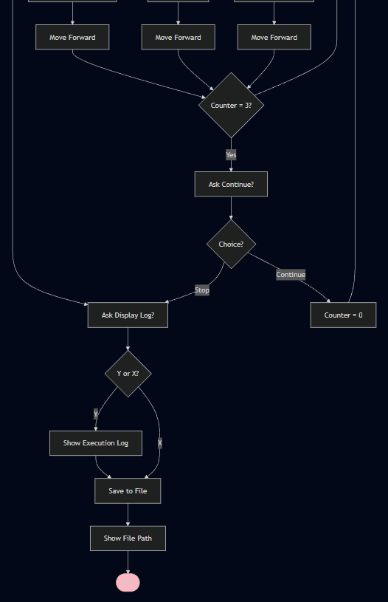
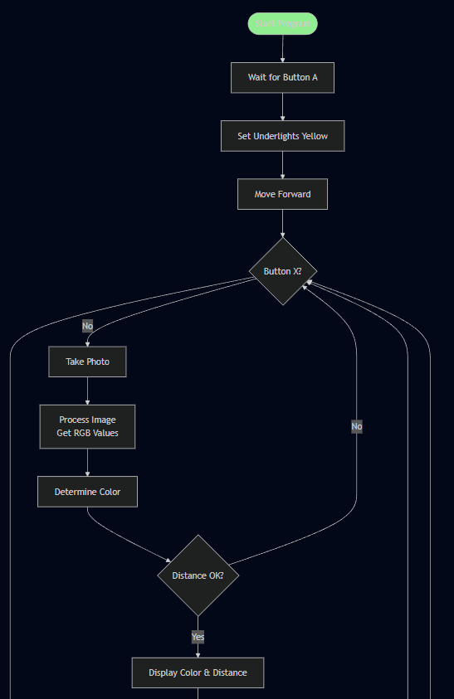
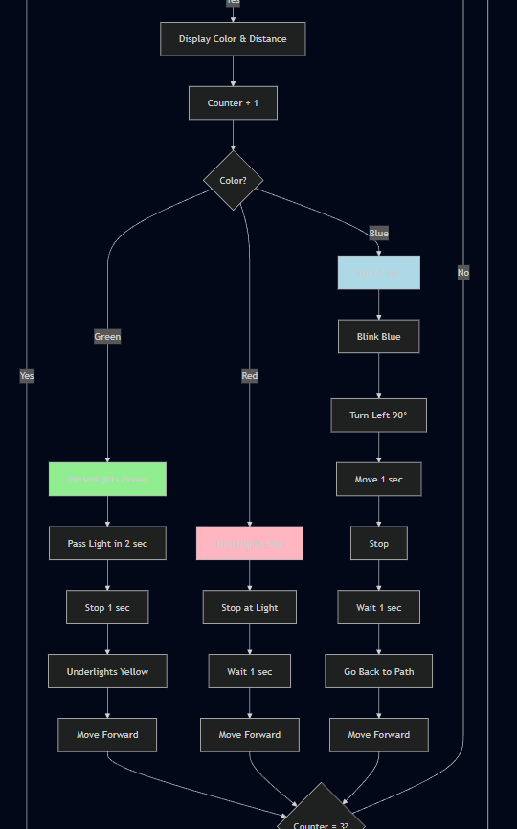
3.
2.
1.

c) Improvements I made to the LLM generated algorithm design
- LLM generated flowchart did not follow a professional structure
One of the first issues is the structure and presentation. The LLM version has inconsistent symbol sizes, which reduces readability of the flowchart and shows a lack of professionalism. To improve, I maintained similar sized boxes and left consistent spaces between steps to improve the overall appearance. As a result, I’ve made it clearer and easier to understand, which is one of the main characteristics of a good flowchart. Another major improvement was to improve the modularity. I divided this complex algorithm into smaller, manageable parts, and then created a separate flowchart for each subprocess. This is a characteristic of a good algorithm design.

- LLM generated flowchart failed to initialise the counter variable and use it properly
Claude’s design missed out the initialisation of variables. For example, in screenshot number 2, after ‘Display colour and distance’, its next step was ‘Counter + 1’. Any reader of this flowchart wouldn’t know what ‘Counter’ is as the flowchart never initialised this variable in earlier stages. This introduces ambiguity throughout the flowchart and breaks logical flow. To improve, in my ‘Initialise System’ subprocess, I distinctly created a variable called ‘lightCount’ and set this to 0 at the start of the entire program, so that every time a light is detected, it will increment by 1, as shown by ‘lightCount = lightCount + 1’. This ensures variables are properly declared. Another issue with the counter in the design was with prompting to terminate the program after every three lights detected. It used ‘Counter = 3’. First, ‘Counter’ was never initialised at the start, and second, this logic is incorrect as it only checks whether there are just three lights detected, not every third light. To correct this, I changed the logic to ‘Counter mod 3 = 0’ to check the 3rd, 6th, 9th lights.
- LLM generated flowchart lacked specifics and detail throughout
Initial Speed:
Even though flowcharts shouldn’t be written in full detail, it should still be specific in exactly what and how the program is expected to run. However, the LLM algorithm design skipped major details. One place is where it states ‘Move Forward’ at the beginning, where it’s missing piece of information regarding the speed. This flowchart fails to specify the SwiftBot’s speed. To improve, I clearly set the initialSpeed to whichever mode the user chooses, as described as my additional feature. I then used this in the ‘Detect Traffic Light’ subprocess and explicitly wrote ‘Move forward at initialSpeed’ to show the speed it will move at.
Distance:
The LLM flowchart included a decision box with the question ‘Distance OK?’. This is significantly vague as we do not know what ‘OK’ classifies as. In my improved design, I replaced this with ‘is distance ≤ 30cm?’ to show the clear value. This took away the vagueness of the LLM flowchart, for clearer understanding.
Image processing:
Another vague section was where it says ‘Process image and Get RGB values’. This very briefly touches over the processing of the image to determine the colour. It completely lacked the core processing . To improve, I expanded this, by creating an entire subprocess. For example, I explicitly stated how exactly the system should check through each pixel and how to extract average RGB values, to determine the colour. This ensured correct logic and made it easy to trace through each step.
- LLM generated flowchart did not include any sort of error handling for inputs
The LLM flowchart didn’t mention validating user inputs and what should occur if the user input is something different to what the system was expecting. I improved this by validating all inputs and displaying appropriate error messages where needed. This ensures that errors are accounted for in the system, to better represent the system.
d) The improved algorithm design

